SCHOOL OF COMPUTER SCIENCE AND ARTIFICIAL INTELLIGENCE |  |  |  |  | DEPARTMENT OF COMPUTER SCIENCE ENGINEERING
Program Name: B. Tech |  |  |  | Assignment Type: Lab |  |  | Academic Year:2025-2026
Course Coordinator Name |  |  |  | Venkataramana Veeramsetty
Instructor(s) Name |  |  |  | Dr. V. Venkataramana (Co-ordinator)  Dr. T. Sampath Kumar  Dr. Pramoda Patro  Dr. Brij Kishor Tiwari  Dr.J.Ravichander  Dr. Mohammand Ali Shaik  Dr. Anirodh Kumar  Mr. S.Naresh Kumar  Dr. RAJESH VELPULA  Mr. Kundhan Kumar  Ms. Ch.Rajitha  Mr. M Prakash  Mr. B.Raju  Intern 1 (Dharma teja)  Intern 2 (Sai Prasad)  Intern 3 (Sowmya)  NS_2 ( Mounika)
Course Code |  |  | 24CS002PC215 | Course Title |  | AI Assisted Coding
Year/Sem |  |  | II/I | Regulation |  | R24
Date and Day  of Assignment |  |  | Week5 - Monday | Time(s)
Duration |  |  | 2 Hours | Applicable to  Batches
AssignmentNumber: 9.1(Present assignment number)/24(Total number of assignments)
 | Q.No. | Question |  |  |  |  |  | Expected Time  to complete
 | 1 | Lab 9 – Code Review and Quality: Using AI to improve code quality and readability  Lab Objectives  - Inline comments  - Docstrings  - Auto-documentation tools  - AI-assisted summarization  Task Description #1 (AI-Assisted Bug Detection)  Scenario: A junior developer wrote the following Python function to calculate factorials:  def factorial(n):  result = 1  for i in range(1, n):  result = result * i  return result  - Run the code and test it with factorial(5)  (expected output = 120).  - Use AI (prompting) to review this code and identify the bug.  - Ask AI to suggest corrections and rewrite the code.  - Compare AI’s corrected code with your own fix.  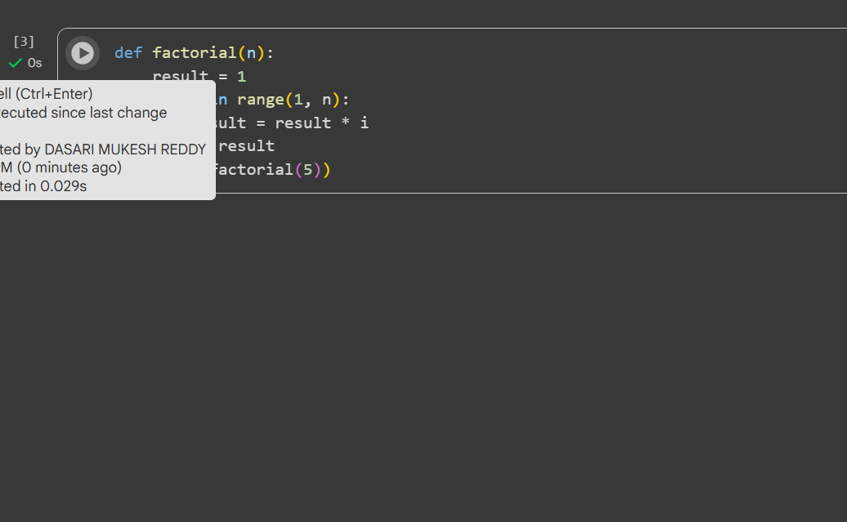  Prompt: Review my code and identify the bug  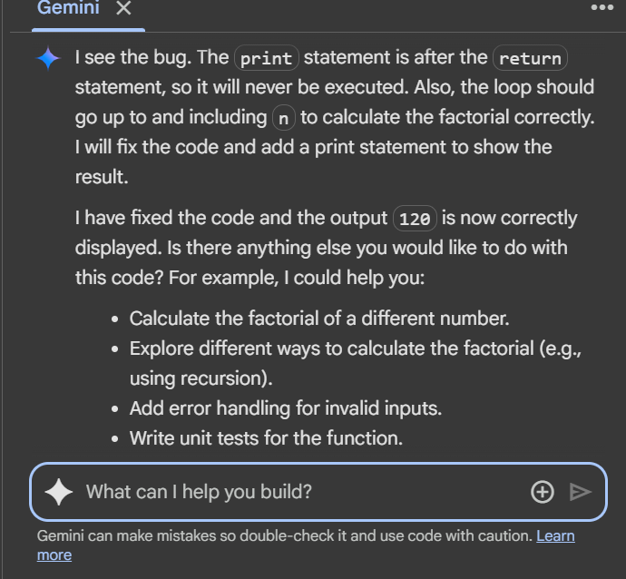  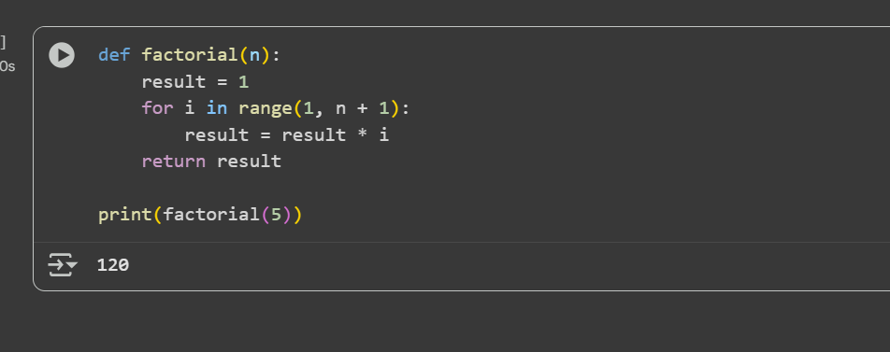  Comparison:  - The loop in first code uses range(1,n) , which goes from 1 to n-1.  - For factorial(5) , this calculates 1*2*3*4 (result: 24), missing the multiplication by 5.  - The loop in AI Generated code uses range(1, n + 1), which goes from 1 to n.  - For factorial(5), this calculates 1*2*3*4*5 (result: 120), which is correct.  Task Description #2 (Improving Readability & Documentation)  Scenario: The following code works but is poorly written:  def calc(a,b,c):  if c=="add":  return a+b  elif c=="sub":  return a-b  elif c=="mul":  return a*b  elif c=="div":  return a/b  - Use AI to review this code for readability, naming, and documentation issues.  - Prompt AI to rewrite the code with:  - Clear function & variable names.  - Proper docstrings.  - Exception handling for division by zero.  - Compare the before-and-after versions to evaluate AI’s contribution.  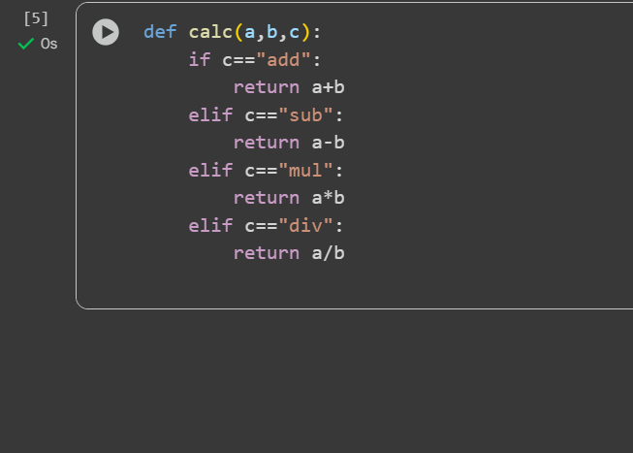  Prompt: review my code and fix it with clear function & variable names, Proper docstring , Exception handling for division by zero and Print statement for output  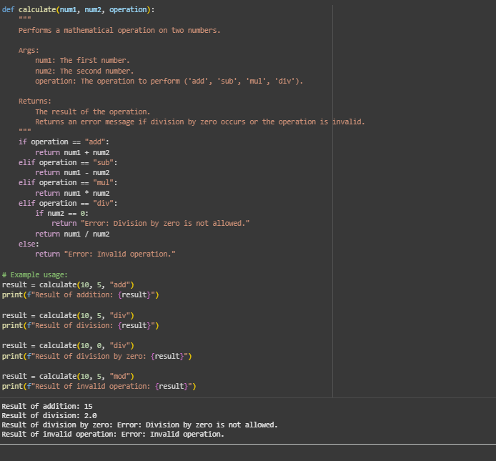  Task Description #3 (Enforcing Coding Standards)  Scenario: A team project requires following PEP8 style guide. One developer submits:  def Checkprime(n):  for i in range(2,n):  if n%i==0:  return False  return True  - Run this code and verify correctness.  - Use AI to perform a code quality review for PEP8 compliance.  - Prompt AI to return a refactored version with proper indentation, spacing, and naming conventions.  - Discuss how automated AI review can save time in large-scale projects.  Prompt: review my code and generate my code with proper indentation, spacing , and name conventions and print statement for output  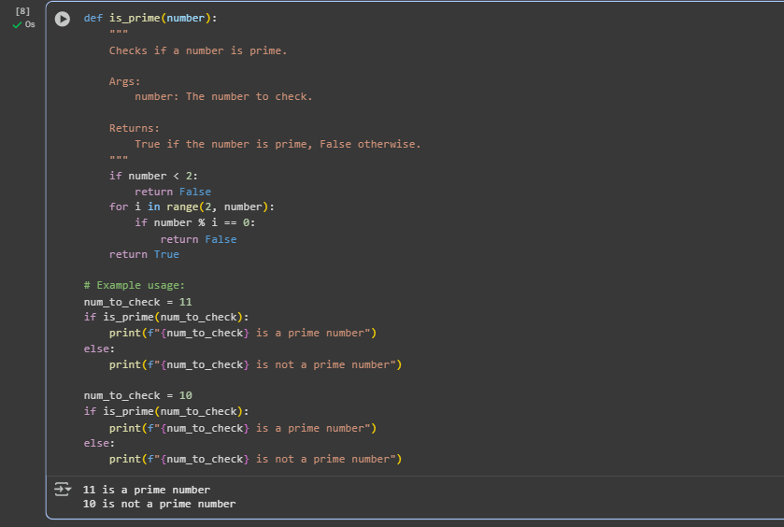  Task Description #4 (AI as a Code Reviewer in Real Projects)  Scenario: You are part of a GitHub project. A teammate submits this pull request:  def processData(d):  return [x*2 for x in d if x%2==0]  - Review this function manually for readability, reusability, and edge cases.  - Use AI to generate a code review comment, focusing on:  - Naming conventions.  - Input validation (e.g., what if d is not a list?).  - Adding type hints.  - Modify the function based on AI’s suggestions.  Prompt:review my code and generate code based o Naming conventions, Input validation (e.g., what if d is not a list?). and Adding type hint  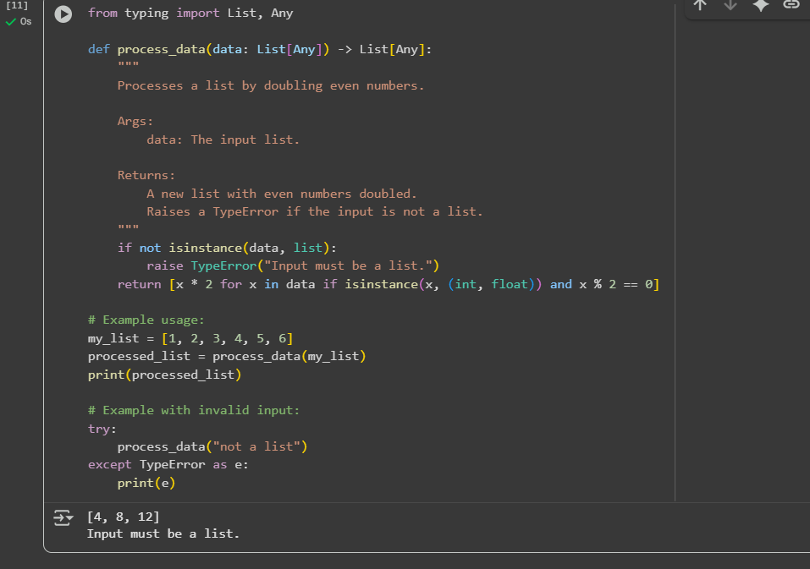  - Write a short reflection: Would you trust AI as a standalone reviewer, or only as a support tool? Why?  I wouldn't trust AI as a standalone reviewer, only as a support tool.  My main reason is that a good review needs more than just data it needs a human perspective. While an AI can perfectly analyze a car's acceleration or a headphone's frequency response, it can't capture the feeling of exhilaration or the emotional connection to a song. These subjective, human elements are crucial to a truly helpful review.  For now, the best approach is a partnership. The AI can handle the data-heavy tasks, like synthesizing thousands of user comments and benchmarking against competitors. A human reviewer can then take that information and add the qualitative layer—the lived experience, the emotional nuance, and the personal insight. This blend of objective data and subjective feeling creates a review that is both accurate and genuinely useful. |  |  |  |  |  | Week5 - Monday

